Horizon Europe PROJECT PARTNER SEARCH
for Cluster 4 calls - Material Science and Manufacturing Technology
About us
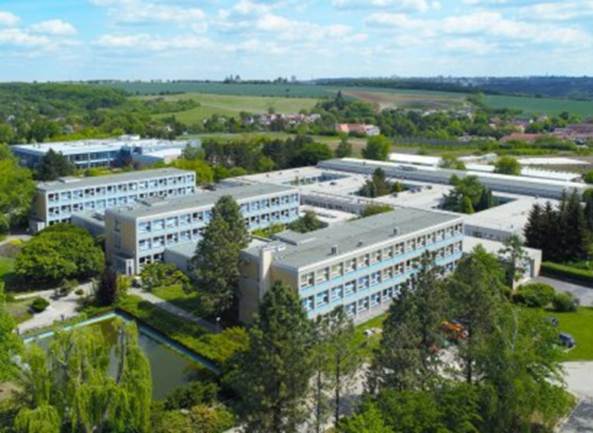
The Faculty of Engineering is a part of the Czech University of Life Sciences in Prague (CZU), in the Czech Republic. This faculty was established in 1952 to solve technical problems focused on agriculture engineering and educate students on these topics. An integral part of the faculty is a prototype laboratory, laboratory of numerical simulation, laboratory of microscopy, laboratory of heat treatment, and others that keep up with current technological developments in the agrarian sector.
The department of Material Science and Manufacturing Technology, as a part of the Faculty of Engineering, is well equipped with state-of-the-art machinery and equipment for development, testing, microscopy and characterization of fiber-reinforced composites.
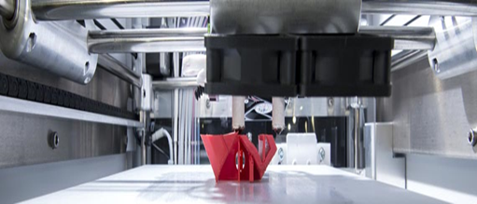
Further, the computational tools for modeling and predicting mechanical performance are also available. The research team is highly experienced in this area and has recently participated in many significant research projects.
CZU holds the prestigious HR Excellence in Research Award, granted by European Commission. So we can guarantee a transparent educational and scientific research environment to our researchers.
PARTNER INFORMATION
Our research team has extensive experience with projects that have been awarded grants from EU Programmes. Our most important projects are as follows:
- Hybrid Materials for Hierarchical Structures (HyHi, Reg. No. CZ.02.1.01/0.0/0.0/16_019/0000843), Ministry of Education, Youth and Sports, Czech Republic.
- Modular platform for autonomous chassis of specialized electric vehicles for freight and equipment transportation”, Reg. No. CZ.02.1.01/0.0/0.0 /16_025/0007293, Ministry of Education, Youth and Sports, Czech Republic.
- Research services, design, development & supply of advanced insulation materials, DEBEL/MMG/PO/FE/DEB-110/03/2013-14, Ministry of defence, Govt. of India.
- Development of prototype of alcohol-fuelled LTAIN19029, MSMT, INTER-EXCELLENCE CR-Indie
- R&D of working tools of agricultural machines, TA04021078, Technology Agency of the Czech Republic
- Research and development of wear-resistant materials and technologies for their use at agricultural machines TA01010192, Technology Agency of the Czech Republic
CZU participates in numerous academic, business, social and other networks and associations. We collaborate with both academic and non-academic partners from Czechia, Europe and Asia.
Researchers from the Faculty of Engineering would like to join the consortium as a project partner to contribute to the calls as mentioned below.
HORIZON EUROPE TOPICS OF INTEREST – CLUSTER 4
Call title | Description | Action type
HORIZON-CL4-2022-DIGITAL-EMERGING-01-06 | Pushing the limit of physical  intelligence and performance | RIA
HORIZON-CL4-2022-DIGITAL-EMERGING-02-20 | 2D-material-based composites, coatings and foams | IA
HORIZON-CL4-2022-RESILIENCE-01-04 | Developing digital platforms for the small scale extractive industry | IA
HORIZON-CL4-2022-RESILIENCE-01-10 | Innovative materials for advanced (nano)electronic components and systems | RIA
HORIZON-CL4-2022-RESILIENCE-01-11 | Advanced lightweight materials for energy efficient structures | RIA
HORIZON-CL4-2022-RESILIENCE-01-12 | Functional multi-material components and structures | RIA
HORIZON-CL4-2022-RESILIENCE-01-13 | Smart and multifunctional biomaterials for health innovations | RIA
HORIZON-CL4-2022-RESILIENCE-01-16 | Building and renovating by exploiting advanced materials for energy and resources efficient management | IA
HORIZON-CL4-2022-RESILIENCE-01-19 | Advanced materials modelling and characterisation | RIA
HORIZON-CL4-2022-RESILIENCE-01-24 | Novel materials for supercapacitor energy storage | RIA

Expertise
Our research team has comprehensive expertise in the following areas:
- development and characterization of fibrous geometries for composite reinforcement
- hybrid adhesive bonds and their characterization using computational as well as experimental techniques
- computational modeling and prediction of fiber-reinforced composite materials performance winding, autonomous vehicles
- evaluation of microscopic internal structures, fracture and morphology
- quasi-static testing, cyclic loading, woven architecture
Infrastructure
- mechanical testing and evaluation under tensile, bending, compression, impact mode
- scanning electron microscopy
- nanoscale mechanical evaluation
- tribology, vacuum infusion
- granulation line
- plastic injection moulding, hardness measuring
- temperature and degradation chambers
- CNC cutting by water jet technology
- particle analyser
Description of the Research Team
Supervisor:
doc. Rajesh Kumar Mishra, Ph.D.

Current position: docent (Associate professor)

Professional profile:
- Number of published papers: 172
- Hirsch index – Web of Science (23), Scopus (25)
- Membership of a scientific org./boards – Member of textile bioengineering and informatics society, Institute of Engineers (India), Textile Institute (Manchester).
- Awards – Outstanding young researcher award from textile bioengineering and informatics society - 2019
- Number of promoted PhD students etc.- 5 (successfully defended theses), 1 continuing

Professional experience:
- 2019- present – Associate professor (docent) at Faculty of Engineering, Czech university of Life Sciences Prague.
- 2013 - 2019 - Associate professor (docent), Technical University of Liberec, Faculty of Textile Engineering
- 2009 - 2013- Assistant professor, Technical University of Liberec, Faculty of Textile Engineering
- 2006 - 2009 – Research & Development Manager in Indian Textile Industry
- 2003 - 2006 – Research Fellow at IIT Delhi
- 1998 - 2003- Lecturer in Textile Engineering at Utkal University, INDIA
Titles and education:
- 2013 - docent, habilitation in textile technics and material engineering from Technical University of Liberec, Czech Republic.
- 2006 - PhD with thesis titled “High quality woven fabric design engineering” from IIT, Delhi, India.
- 1998 - B.Tech. from Textile faculty in Utkal University, India.
Specialization: fiber-reinforced composites, green composites, biological fillers for composites, nanocomposites, biomechanical engineering of fibrous structures, thermo-mechanical characterization of materials, thermal behavior of textile structures etc.
Team members:
- Team member: prof. Ing. Miroslav Müller, Ph.D.
Specialization: polymer composite materials, hybrid adhesive bonds, material use of secondary renewable raw materials, i.e. waste, wear, material machining - waterjet technology.
- Team member: Ing. Monika Hromasová, Ph.D.
Specialization: scanning Electron Microscopy, evaluation of fracture and morphology
- Team member: Ing. Viktor Kolář, Ph.D.
Specialization: mechanical characterization, quasi static testing, cyclic loading and evaluation of composites
- Team member: doc. Ing. Michal Petrů, Ph.D.
Specialization: fiber-reinforced composite, modeling and simulation, robotic winding, autonomous vehicles.
- Team member: prof. Bijoya Kumar Behera, Ph.D.
Specialization: textile structural composites, computational modeling, woven architecture
- Team member: prof. Prasad Potluri, Ph.D.
Specialization: textile reinforced composites, braiding, numerical modeling
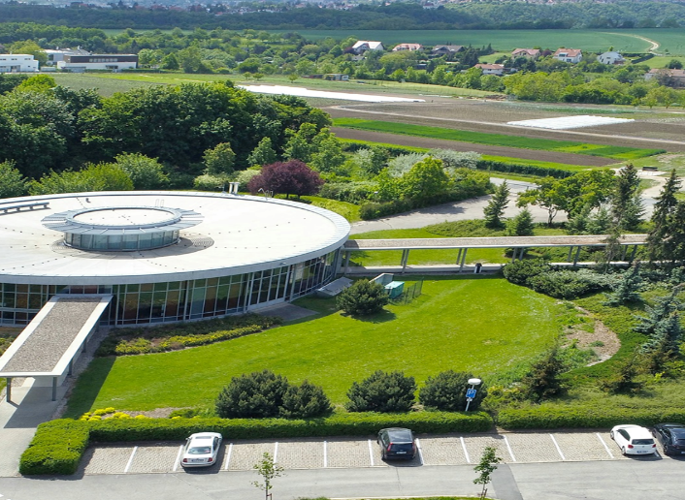
Contact us
Pavlina Ruzickova, project manager
Email: ruzickova@tf.czu.cz

https://www.tf.czu.cz/en

https://www.facebook.com/tf.czu.cz

https://www.instagram.com/tfczucz/
https://www.youtube.com/c/czu

